ENVIRONMENTAL SCIENCE

FIRST SESSIONAL EXAMINATION

SECTION – A

Q1. Attempt all parts:

1. Herbivores are--------consumers.

Answer: Primary

1. The term ecology was coined by---------.

Answer: E.Haeckel

1. The term ecosystem was coined by--------.

Answer: A.G.Tansley

1. Increase in fauna and decrease in flora would be harmful due to increase in----------.

Answer: CO2

Q2. Attempt all parts:

1. Give the example of manmade and natural ecosystem?

Answer: The examples of manmade ecosystem are: Zoo, village, Garden, Aquarium, crop field etc.

The examples of natural ecosystem are: Desert, Forest, Grassland, etc.

1. Name the different types of food chain?

Answer: There are three different types of food chain :

1. Grazing food chain.
2. Detritus food chain.
3. Parasitic food chain.

SECTION – B

1. Discuss the different steps of Nitrogen cycle?

Answer: Nitrogen is the essential micro-nutrient (required in large amount) for the plant and animal growth. The major amount of nitrogen is gaseous and thus present in atmosphere. Plants cannot absorb the gas. Thus it is converted to some other absorbable form by nature described below:

*Processes in Nitrogen cycle:*

*A. Nitrogen Fixation:* The process of converting atmospheric nitrogen to the form which plants can absorb is known as Nitrogen Fixation.

*TYPES OF NITROGEN FIXATION:*

1. *Atmospheric Nitrogen Fixation:*

Nitrogen molecules + Oxygen molecules 🡪 Nitrates(taken by plants).

1. *Biological/Biotic Nitrogen Fixation:*

By certain micro-organisms:

i.Rhizobium is a symbiotic bacteria (Rhizobium bacteria lives in the root modules of leguminous plants.)

ii. Azotobacter and Clostridium are free living bacteria.

iii. Amabaena and Nostac are some cyanobacteria.

*3.Industrial Nitrogen Fixation:*

In industries , at high temperature, pressure and catalyst.

Nitrogen + Oxygen🡪 Ammonia

*B. Decomposition:*

Decomposers breakdown the dead and decaying organic matter. The most stable product of decomposition is ammonia.

*C. Nitrification:*

Nitrifying bacteria convert ammonia to nitrite (Nitrosomonas) to nitrate (nitrobactor).

*D. Denitrification:*

Dentrifying bacteria returns Nitrogen to atmosphere (in the absence of oxygen) , e.g. Pseudomonas.

B Briefly describe the need of public awareness about the environment?

Answer:

The activities help in creating awareness among public are

1.Join a group to study nature such as WWF-I or BNHS or any other organization

Read newspaper articles and periodicals like Down to earth, WWF-I newsletter, BNHS, Hornbill, Sanctuary magazine.

2.Discuss environmental issues with friends and relatives.

3.Join local movements that support activities like saving trees in your locality, reducing use of plastics, going for nature treks, practicing 3 Rs i.e. reduce, reuse, & recycle.

4.Practice and promote good civic sense and hygiene such as enforcing no spitting or tobacco chewing, no throwing garbage on the road and no urinating in public places.

5.Take part in events organized on World Environment Day, Wildlife week etc.

6.Visit a National park or sanctuary or spend time in whatever natural habitat you have near your home.

c.Discuss the role of producers, consumers and decomposers in an ecosystem?

Answer:

* Role of producers in an ecosystem:

Producers are also known as autotrophs, since all the green plants have chlorophyll, with the help of sunlight and chlorophyll plants prepare the food material in the form of carbohydrates.

* Role of consumers in an ecosystem:

Consumers are known as heterotrophs. All animals come under this category. Depending upon the feeding habit are of three types:

1.Herbivores: Plants eaters cow, goat, deer, elephant, etc.

2.Carnivores: Meat eaters lions, tigers, wolf, etc.

3.Omnivores: Plant as well as meat eaters, birds, humans, rats, etc.

* Role of decomposers in an ecosystem:

They are also known as saprotrophs, these organisms obtain their food from the dead bodies of plants and animals. They clean the nature so they are also known as natural scavengers.

Examples are Bacteria, Fungi, etc.

SECTION – C

Q4. Answer any one of the following :

1. Differentiate between Desert Ecosystem and Grassland Ecosystem.

Answer: Grassland Ecosystem:

Grasslands occupy about 19% of the earth’s surface. The major grassland ecosystems of the world are the great plains of Canada and United States, S. Argentina to Brazil and S. Asia to Central Asia.

Abiotic substances:

These include the nutrients present in the soil and the aerial environment. The elements required by plants are hydrogen, oxygen, nitrogen, phosphorous and sulphur.

Producers---These are mainly grasses of the family, Graminae, a large variety of herbs, some shrubs and scattered trees.

Consumers: Herbivores such as grazing mammals (e.g., cows, sheep, deer, rabbit, buf­faloes, etc), insects (e.g., Dysdercus, Coccinella, Leptocorisa, etc),

Decomposers: These include bacteria of death and decay, moulds and fungi (e.g., Mitcor, Penicillium, Aspergillus, Rhizopus, etc).

The Desert Ecosystem:

The deserts occupy about 17% of the land and occur in the regions with an average rainfall of less than 23 cm.

The shrubs, bushes, grasses and some trees are the main producers in deserts.

Consumers:mOnly a few animals are found in deserts. The most common animals are those reptiles and insects which are able to live under xeric conditions.

Decomposers:Due to poor vegetation and less amount of dead organic matter decom­posers are few. They are thermophilic fungi and bacteria.

1. Discuss the biotic and abiotic component of forest ecosystem?

Answer:

Forest ecosystem: A forest is a community of trees, herbs, shrubs, and associated organism that use oxygen, water and soil nutrient for their growth and reproduction.

Producers of forest system: Big trees, medium sized bush, small herbaceous plant or any vegetation of the forest which performed photosynthesis.

Consumers:

* Primary consumers: They graze over the producers. Examples: Elephants, deer, goat, birds, insects like flies, spiders, ants.
* Secondary consumers: They are the predators of the primary consumers. Examples: Jackal, Fox, Eagles, etc.
* Tertiary consumers: They feed on secondary consumers. Examples: Lion, Tigers, etc.

Decomposers: They have the ability to degrade all dead organism to release nutrient into the soil which are again used by the producers. Examples: Earthworms, Bacteria, Fungi, etc.

Q5. Answer any one of the following:

1. Explain photosynthesis and transfer of energy from one consumer to another in abiotic world.

Photosynthesis is the process by which **plants use sunlight, water, and carbon dioxide to create oxygen and energy in the form of sugar**

**When energy is transformed from one form to another**, or moved from one place to another, or from one system to another there is energy loss. This means that when energy is converted to a different form, some of the input energy is turned into a highly disordered form of energy, like heat.

Energy enters all ecosystems as sunlight and is gradually lost as heat back into the environment. However, before energy flows out of the ecosystem as heat, it flows between organisms in a process called **energy flow**

The waste and dead matter are broken down by decomposers and the nutrients are recycled into the soil to be taken up again by plants, but most of the energy is **changed to heat** during this process. On average, only about 10 percent of energy stored as biomass in a trophic level is passed from one level to the next

1. What are ecological pyramids? Name the different types of ecological pyramids? Which type of ecological pyramid is always upright in shape and why?

Answer: The graphical representation of food chain in an triangle form is known as an ecological pyramid.

This concept was given by Charles Elton.

There are three types of ecological pyramid:

* Pyramid of Number
* Pyramid of Biomass
* Pyramid of Energy

The shape of pyramid :

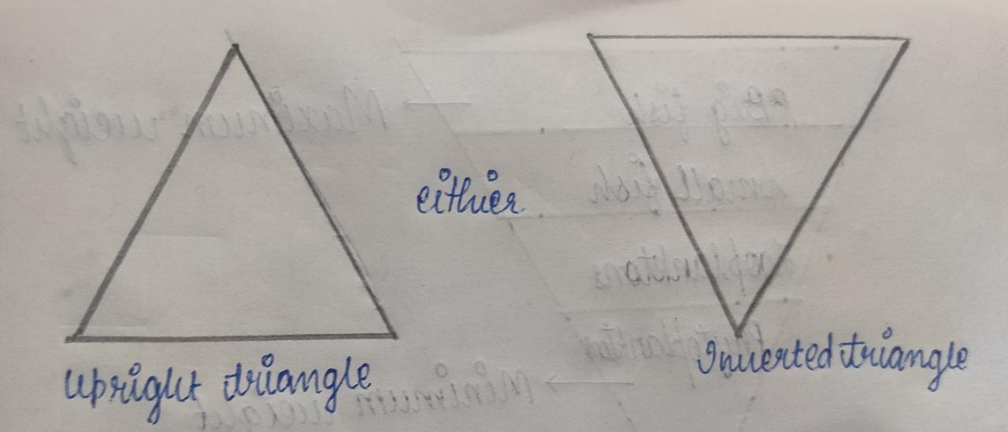

* Pyramid of Number: It represents the total number of individual present in each trophic level in an ecosystem.

In case of forest ecosystem, grassland ecosystem, pond ecosystem, the shape of pyramid of numbers is upright triangle.

On the other hand, in case of tree ecosystem, the pyramid of number is inverted triangle.

* Pyramid of Biomass: It represents the total amount of weight of organism present in each trophic level in an ecosystem. Examples: Forest ecosystem, grassland ecosystem and tree ecosystem.

The shape of pyramid of Primass is upright triangle.

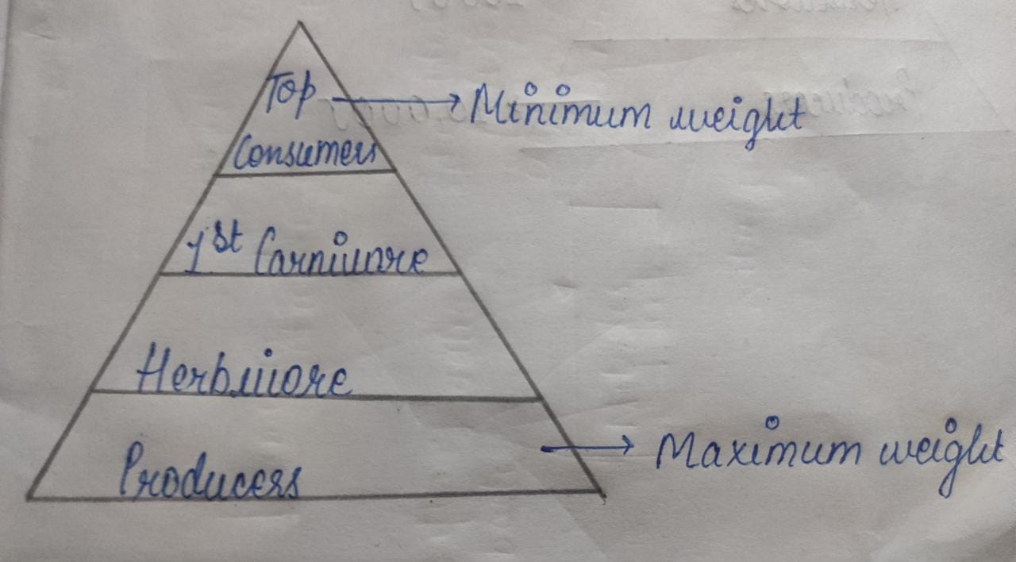

1. Tree ecosystem
2. Forest ecosystem
3. Grassland ecosystem

* Pyramid of Energy: It represent the total amount of energy present in each trophic level in an ecosystem.

Pyramid of energy is always upright triangle because during the transfer of energy only 10% energy is transferred and rest 90% is lost i.e., producers have maximum energy and top consumers have least energy.